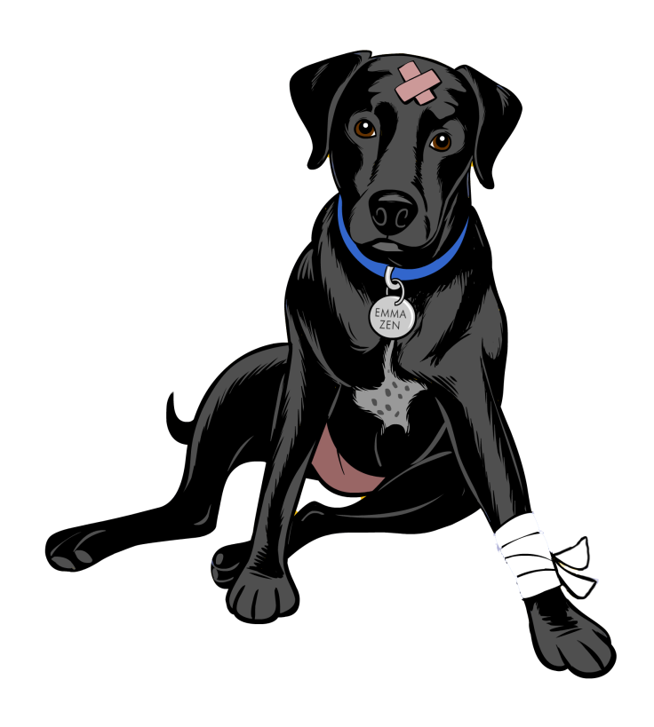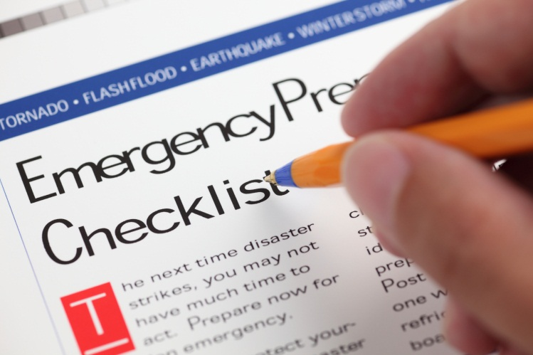

**REGISTER ONLINE AT** [**WWW.EMMAZENFOUNDATION.COM**](http://WWW.EMMAZENFOUNDATION.COM) **OR CALL 714 742 8895**

● Learn what to put in an **emergency preparedness kit**

● Learn how to build your own **Pet First Aid Kit**

● Prepare for what to do in case of **evacuation**

● Discuss treatments for **snake bites, over heating**

● Practice techniques for dealing with   
 **Bleeding, Choking & Pet CPR**

● Safety Games ® and **what to do in case of fire**

● **Questions and Answers**

**June 1st, 2013**

**Wrightwood Community Center**

**10 AM – 12:30**

**1275 St Hwy 2, Wrightwood**

**$25.00 Per Person and all proceeds support   
Pet Oxygen Masks for San Bernardino Fire Departments**

**2 ½ hours with Pet First Aid & CPR instructor   
Debra Jo Chiapuzio   
President of the Emma Zen Foundation**

**A 501 c 3 supporting Pet Safety!**

Pet Safety Seminar