Join Us at:
Homewood Suites by Hilton in Lancaster
2320 Double Play Way, Lancaster CA 93536
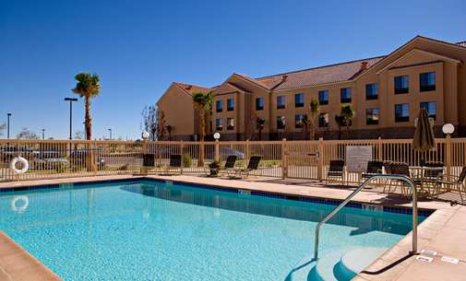 | 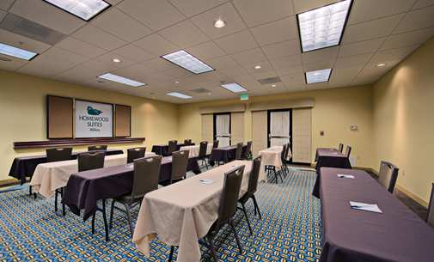
Come Learn Pet First Aid & CPR October 25th from 1- 6 PM
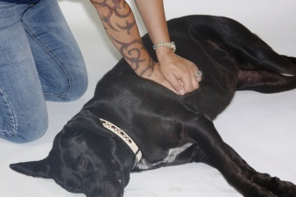
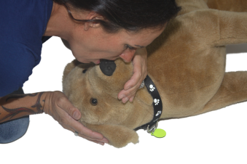
You must register online or
RSVP through the online contact form
Space is limited, sign up now!
www.doggieandme.com
or call us at 714 742 – 8895
Instructor Debra Jo Chiapuzio
Your course is 5 hours long, includes extensive training
a pet first aid manual, certification of class, snack time and
hands on practice with resuscitation critters!
It is estimated that 92%  of dogs and cats will experience an  emergency during their lifetime, and  according to The American Animal  Hospital Association, 25% more of  them could be saved if just one was applied prior to them getting professional veterinary care? | 