Pet CPR
- NEVER preform CPR on a pet that is breathing or has a pulse!!!
- LOOK LISTEN AND FEEL FOR BREATHING
- Pull chin back to open airway
- Give 2 quick breathes into the nostrils
- LOOK LISTEN AND FEEL FOR BREATHING ------
- Check the femoral artery for a pulse -------
- If the pet is not breathing but there is a pulse, preform rescue breathing!
10 Breathes for every 30 seconds
15 breathes for every 30 seconds for smaller pets
- If the pet is not breathing and has no pulse, begin CPR!
- Begin by Finding the Target Zone for CPR
- 30:2 (30 compressions to 2 breathes)
- Large Breeds 60 pounds and up; 60 compressions per minute
Medium 60 – 120 compressions per minute
Under 10 pounds 120 compressions per minute
- Preform 3 or 4 cycles then recheck vitals
- Quickly transport pet to the nearest Animal Emergency Center
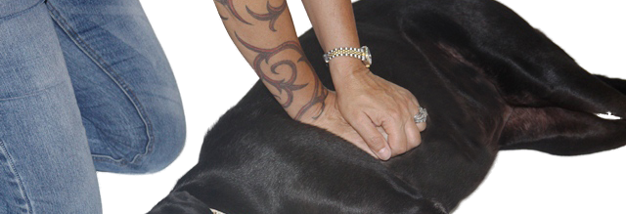
www.doggieandme.com

