Heat Stroke IS Preventable!
The #1 cause of Heat Stroke is still being left in the car!
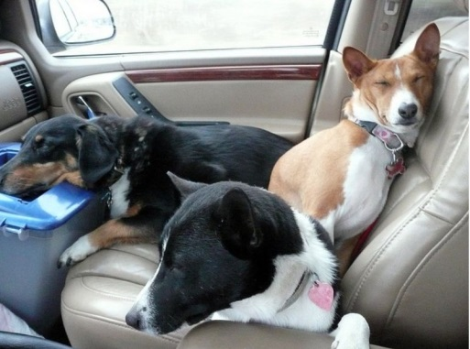
- Never leave your pet in the car even with the windows down.
- Make sure indoor pets have ventilation.
- Make sure outdoor pets have shade.
- Both should have a fresh replenishing supply of water.
- Walk your pets in the early morning or late afternoon on hot days.
- Do not “dress” your pet on warm days.
- Keep your pets “pads” in mine on surfaces such as hot asphalt.
- Keep your pet in shape! Being overweight can cause an onset of heatstroke.
- Watch those that are Brachycephalic (short nosed)
- Keep your pet properly groomed, over matted can cause an onset of heatstroke.
- Don’t “shave” your pet proper groom allow for the pet to dispel heat naturally.

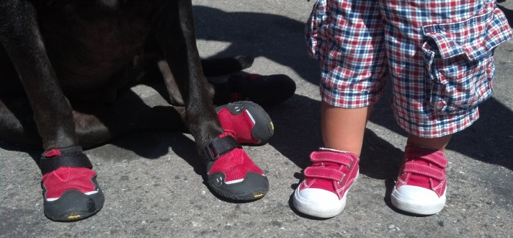 | Shoes both prevent burns and cause over heating!  Please use them properly!  They should be placed on a pet that  is traveling across hot surfaces to prevent burns.  Then removed as soon as possible,  the paw is your pet’s primarily cooling station!

 | 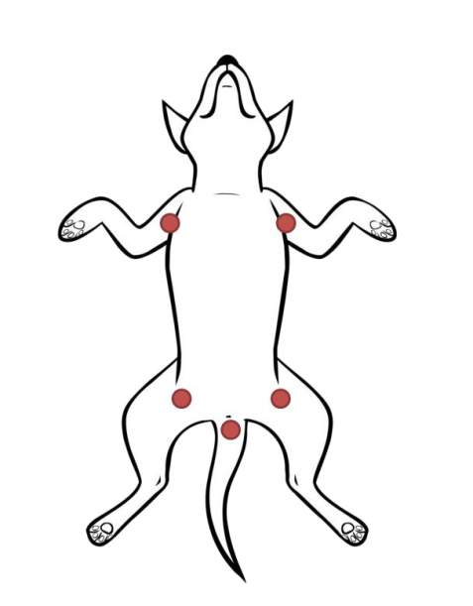 | 