Heat Stroke is PREVENTABLE
The #1 cause of Heat Stroke is still being left in the car!

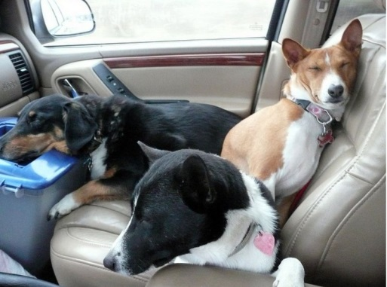
x
- Never leave your pet in the car even with the windows down.
- Make sure indoor pets have ventilation.
- Make sure outdoor pets have shade.
- Both should have a fresh replenishing supply of water.
- Walk your pets in the early morning or late afternoon on hot days.
- Do not “dress” your pet on warm days and use shoes properly.
- Keep your pets “pads” in mine on surfaces such as hot asphalt.
- Keep your pet in shape! Being overweight can cause an onset of heatstroke.
- Watch those that are Brachycephalic (short nosed)
- Keep your pet properly groomed, over matted can cause an onset of heatstroke.
- Don’t “shave” your pet. Proper grooming allows for the pet to dispel heat naturally.
- Use an electrolyte replacer before the onset of heat stroke.
Electrolyte Replacer Formula  1 Quart Fresh Water  (bottled or filtered preferred)  1 Tablespoon Honey  1 Teaspoon Salt  Store in refrigerator but serve at room temperature making a  fresh batch daily. | 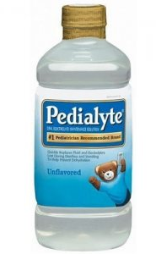 | Throughout the day dose,  3 Tablespoons for puppies/kittens  5 Tablespoons for pets up to 5 lbs.  ¾ cups for pets up to 10 lbs.  ¼ cup per 5 lbs. of body weight for pets 15 lbs. and more

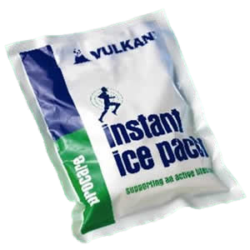 | 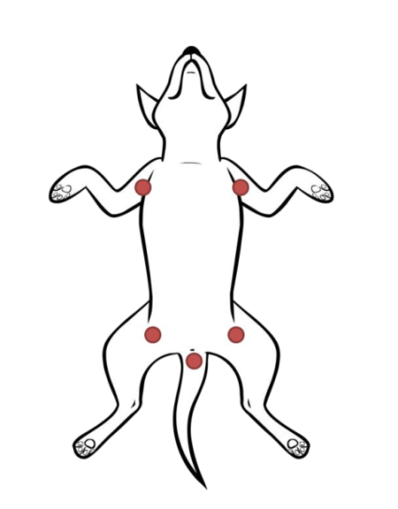 | 