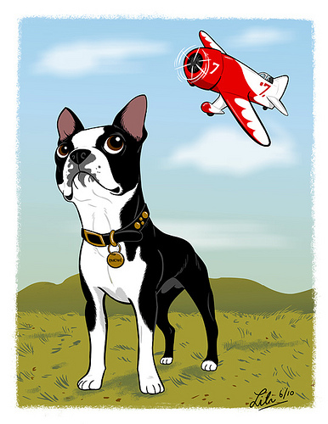

Pick a command that is not similar to one you already use. **“Clear” “Move” “Away”**

Imagine this you are in the kitchen and you drop a glass dish and it shattered! The noise has your dog running towards you to see what happens and you say, “retreat retreat” and instead of having four cut paws you have a good dog   
at a safe distance!

**All rights reserved / Copyrighted 2012**

“OUT” “DOOR” “YARD”

Clear all stations!

Canine Safety Games ™

Emergency situations happen in the blink of an eye and sometimes the safest thing for our pets is to be NO WHERE NEAR US. Wouldn’t it be nice if, in a case like this you could simply give a command that would tell your dog to “Clear” the area! Well now you can with the game Clear all Stations, you can teach your pet to leave an area on command!

TRAINING FOR RETREAT

● Start training outdoors and once the command is learned you should bring it inside.   
● You use a long lead (12 foot or better) to learn come from a distance, now you will do the same thing for retreat. Wrap your lead around a tree so when you pull on the rope the dog is forced to walk away from you!

● Say your command and pull!   
● You MUST approach your dog and reward them for being “away” from you. DO NOT say “good dog” and have them come back to you or you have just rewarded the come!

This training behavior takes a couple different views. If you’re outdoors already you may want to reward you pet for “clearing” you at a certain footage. Then you could build on that distance with practice. However if your indoors you may need to give them a mark to go to. This means showing them where you want them to first and rewarding them for being at that place. Build on this by seeing if you can get your pet to mark from a further and further distance.

LEARN TO MARK

I put a rug at the front door and touch it with my foot and said, “Emma Mark” and when she puts both front feet on it! I reward her with a special treat! Then after they have this move back one foot and point to the rug and say “Mark” let them learn on their own do not push them maybe coach them over with the smell of a treat until they get it. Reward standing on the mat! I can now send her to her “mark” from anywhere in our home! This is how the movie industry trains dogs to appear in films.