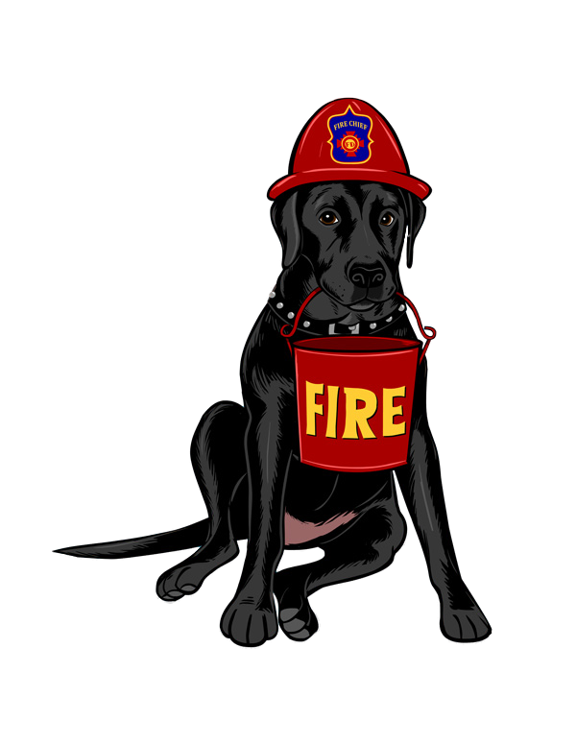­

Fire Alarms and Smoke Detectors

Canine Safety Games ™

Emma “ALARM”



Testing your smoke detectors can not only save your live but can save the life of your pets too. Test your detectors once a month and “play this fire safety game! This skill for your pet is not mean to be learned in a week but a behavior that can be practice throughout your pet’s life. Consistency is a key to training and this training offers a behavior that can help save your pets life!

PET OXYGEN MASKS

The Emma Zen Foundation is a nonprofit organization that provides oxygen masks specifically designed for muzzles of dogs, cats and other household pets. My name is Debra Jo Chiapuzio, President and I thought I would hear “some” stories but I wasn’t prepared for the volume of tales from fire fighters and pet owners that I experienced. Nor was I ready for the overwhelming reality of pets in fires. **Our foundation suggests that you just “be ready” for what if: The unexpected happens to you?**

Home Fires and Carbon Dioxide emergencies are dangers that can affect both you and your pet. Training your dog to respond to signals can ultimately help them to stay safe. Remember only you “knowing” to get out your pet needs help in knowing “what” to do if required.

TRAINING FOR FIRE ALARMS

● Record the sound of your smoke detectors  
using your cell phone.   
● Decide where you want to “meet” your pet during an emergency,

● Start within a close proximately to your pet, play your ringtone, use your tone and word “Emma ALARM” grab you dog my the collar and run to your exit location.   
● Reward your pet!!!   
● Continued training consist of starting in consistently further location and learning how to respond without collar coaching,

Do not pick the word “fire” as you do not want to train using a word that may adversely alert family members or neighbors.

Use the voice fluctuation you think you may use in an emergency situation.

**All rights reserved / Copyrighted 2012**

**BASIC TRAINING COMMANDS**

One of the most overlooked safety techniques is basic training. Your Sit / Stay / Come could save your pets life! Elaborate on them, Stay longer, Sit with distraction, and come weather your insight or not! Make your training fun and evolving and constantly challenging. Solid basic techniques are also the foundation of advance training behaviors.  
  
**REGION SPECIFIC**These exercises were written in California and ironically during an earthquake! Your area may be subject to region specific disasters such as hurricanes, tornadoes, floods, wild fires, environmental disasters and other accidences. Find your warning signal and command that will give you better control of your pet, and tweak these rules to assist your needs.

I don’t know about you but when the earth starts shaking I just naturally sort of loudly say in a panicked voice, “Earth Quake!” So not to disturbed the neighbors for training purpose I choose the word, “QUAKE.”

**TRAINING FOR EARTHQUAKES**● Star with a regular training session so your pet knows your they are practicing behaviors.  
● Shout out your chosen word “QUAKE”   
● Run to your dog grab them by the collar and drag them to under the table with you. Now have “special “ treats. (We used hot dogs.)

● After a few grab and drags your dog should start following you and even learn to dive under that table!

● If you’re going to teach multiple covers, or exits for fire safety, teach them one at a time as independent behaviors.

E A R T H Q U A K E !!!

Canine Safety Games ™

According to the AAHA 25% more pets could survive if one pet first aid technique was applied on scene.   
Debra Jo Chiapuzio is a pet first aid and CPR instructor call (714) 742-8895 for more information

.

DEBRA JO CHIAPUZIO   
www.emmazenfoundation.com   
(714) 742-8895

EMMA ZEN FOUNDATION   
emmazenfoundation@hotmail.com

WWW.FACEBOOK.COM  
/EMMAZENFOUNDATION

**Taking Cover / Dining Room**