Build your own Pet First Aid Kit
doggieandme.com | 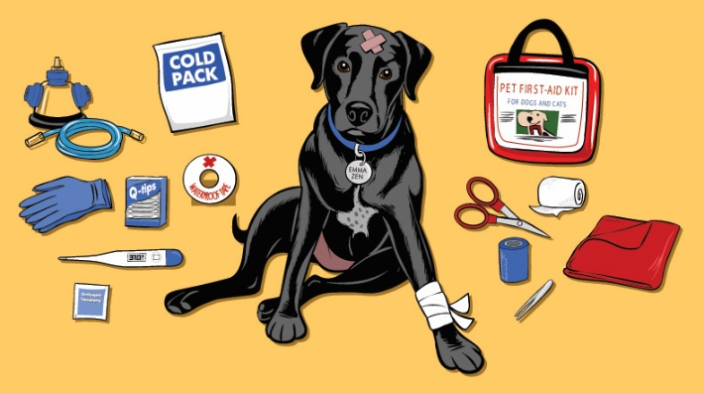 | Because  you can only work  with what you have!

Below is a list of items we suggest for a basic kit;

Latex-Free Gloves (*Nitrile)  Cotton Swabs (*Q-Tips)  Small and Large plastic Syringe (*No needles)  BPS Free Water Bottle (filled)  Blunt Nose Scissors  Ticked-Off Tick Remover  Tweezers  Digital Thermometer  Non-Stick Pads for burns (6)  Gauze Squares (10)  Gauze Rolls (4)  White Adhesive Roll Tape  Flex-Wrap Self-Adhering Elastic Bandage  Triangular Bandage for slings/splints or bandannas  Emergency Blanket  Portable Food and Water Bowl  Emergency Meal and Water  Doggie Walk Bags  Pets Toy  Emergency ID Tag | Pet First Aid Book  Emergency contact names and numbers  Some ER Cash  One-Size-Fits-All Temporary Muzzle  Extra Leashes and or "D" Leash  Cold Packs  Antiseptic Towelettes  3% Hydrogen Peroxide (4 fl oz)  Saline Solution Eye Wash (4 fl oz)  Iodine Swab Sticks / Antiseptic  Triple Antibiotic Ointment (*Neosporin)  1% Hydrocortisone Cream / Anti-inflammatory  Tri-Buffered Aspirin Tablets (Call your Vet for dosage)  Diphen-hydramine Tablets/Antihistamine (*Benadryl)  Diotame Tablets/Antacid (*Tums)  Simethicone / Antacid (*Gas-X)  Antibacterial Soap (*Dial barsoap)  Chlorexidine Cleanser (*Hibiclens) / Disinfect  Water Based Protectant (*K-Y Jelly)  Styptic Powder

Special items in my own kit include;  Pedialyte  Witch Hazel or Vinegar  Gold Bond Powder  (*Vetericyn)  Aloe Vera  Activated Charcoal  Epson Salts | Additional Items in my home;  Ginger Snap Cookies / tummy aches  Pure Pumpkin / Diarrhea or Constipation  Plain Yogurt / Yeast Infection  Mineral Oil  Homeopaths * Additional Education Required  Essential Oils * Additional Education Required  Scan your environment, manage your emotions!

Have your emergency contact numbers in your phone
So you can speak with someone who can help walk you through an emergency situation

