Bleeding Wounds

We would like to discuss some basic rules in regards to bleeding and choking that could be some assistance in cases of emergency. Pet First Aid is NOT a replacement for veterinary care. When dealing with injuries first things first. Make sure you are in a safe environment to help the pet and then always secure your pet. Even your well behaved dog or cat will bite if he or she is in pain.
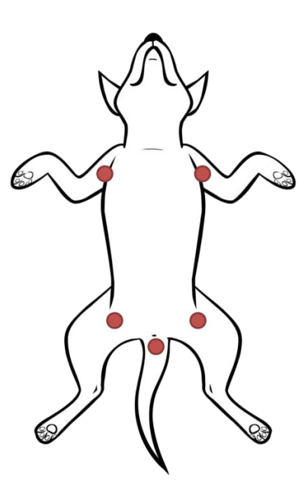 | Minor: Flush with water, saline/eye wash or hydrogen peroxide. Use styptic powder to control bleeding toe nails and watch to make sure injury doesn’t become infected.  Severe: Apply DIRECT PRESSURE with gauze to stop the bleeding. ELEVATE the limb if bleeding hasn’t stopped. Apply PRESSURE to one of the 5 PRESSURE POINTS to diminish blood flow.  You need to maintain pressure long enough for the blood to clot; this can take upwards of 10 to 15 minutes.  Secure with gauze roll bandage and self-adhering bandage making sure you can slip a finger underneath so that it’s not too tight.  Then seek professional help.
Choking

- Give the pet a minute to cough up the object on their own.
- Perform a careful swept of the mouth to remove the object. No blind sweeping.
- Do not pick your pet up: get down on all fours to your pets level.
- You can pick your pet up by the rear end only, wheel barrel style, letting gravity work to assist you.
- Use the heal of your hand to deliver blows between the shoulder blades.
- Preform side compressions with hands on either side of the ribcages.
- You can perform a Heimlich like maneuver on pets.
- Continue the process until they spit it out, swallow it or become unconscious.

Remain Calm…
Choking is not the immediate hazard
Be prepared for what to do after they SPIT IT OUT, SWALLOW IT
or become unconscious. (Refer to page on CPR)
www.doggieandme.com

